

Zoom Support Guide
This guide is designed to provide step-by-step instructions for hosting or supporting a class on Zoom. Some sections rely on using a UMaine Zoom account. These are available to faculty and class volunteers, contact your local senior college for details.
Click on an item in the Table of Contents or use the Ctrl+F keyboard shortcut to find a specific term.
Access Zoom.
Select “Sign in” at the bottom of the screen. You may be asked to enter your maine.edu account name and password.
Share step-by-step support Tip Sheets from the Maine Senior College website with students and instructors.
Contents
Your Role as Zoom Support 3
Before Class 3
During Class 4
After Class 4
Scheduling, sharing, and joining meetings 5
Sharing a Meeting Link 7
Starting a Meeting 7
Creating a Co-Host 11
Participants Joining the Meeting 12
Seeing Zoom Controls in the Meeting 12
Transcription 13
Microphones and Cameras 15
Turn a Microphone or Camera On/Off 15
Trouble Shooting Audio 16
Change Your Background 17
Participating in Class 18
Change Your Screen View 18
Raise Your Hand and Reactions 19
Chat 19
Rename Participants 20
Closed Captioning 20
Sharing a Screen 20
Sharing 20
Showing a Video 22
Advanced Instruction 23
Recording 23
Breakout Rooms 26
Polling 28
Whiteboard 29
iPhone and iPad Users 29
Online support 29
Shortcuts 30

Your Role as Zoom Support

Before Class
Always check that your UMaine account password and your Zoom application are up to date and active. UMaine passwords must be changed every 180 days.

Updating the Zoom App
On Desktop (Windows/Mac):
- Open the Zoom desktop app
- Click on your profile picture in the top right
- Select "Check for Updates"
- If an update is available, click "Update" and follow the prompts
- Restart Zoom after the update completes
On Mobile (iOS/Android):
- Open the App Store (iOS) or Google Play Store (Android)
- Search for "Zoom"
- If an update is available, tap "Update"

During Class
Try to log in 15 minutes prior to the start of class so you can be available to troubleshoot questions from both the instructor and the students.
- Open any documents or video links related to the course so they are ready – even if you’re not planning to share your screen, this is a great backup plan. Close out any applications you do not need for the class.
- Turn on AI Transcription.
- Watch the chat and your email inbox for students who are either unable to access the meeting or having trouble with their camera and microphone.
- Be ready to manage breakout rooms, video streaming, and other in-class activities.
- Don’t forget to start the recording if desired. (Record to the cloud.) Tell the class that recording is starting and confirm they are ok with being recorded.

After Class
If you recorded the session, you should send the link to the class participants.
You will also need to download and save a copy of the transcript in case a student requests it. Transcripts are for individual use solely, to be shared only with students of the class upon request. They are not for sale or sharing.

Scheduling, sharing, and joining meetings
- In the right-hand menu, click on the “waffle” icon and then select Meetings.
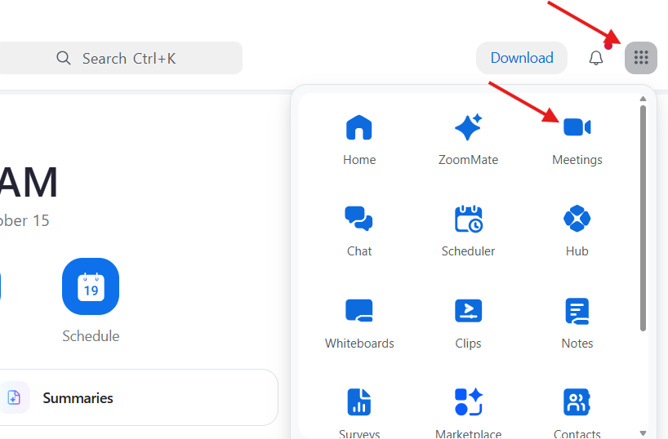
- Here you will see a list of any meetings you may already have scheduled.
- Click on Schedule a Meeting in the upper right.
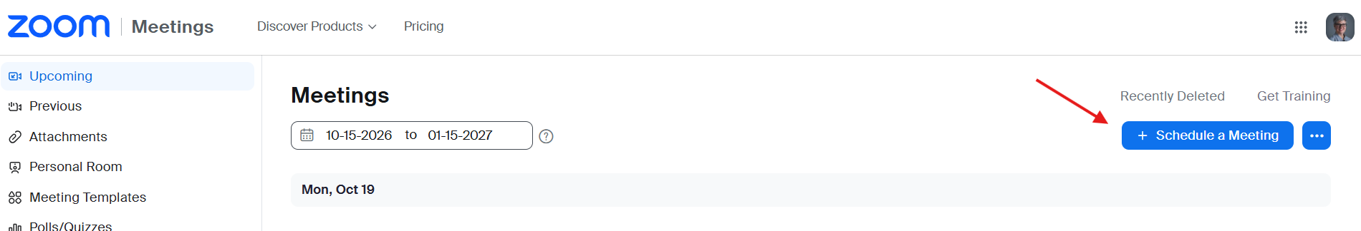
- Complete the fields.
  - Topic: Class name
  - When: First day of class and start time
  - Duration: Length of a single class session
  - Time Zone: Eastern (this is the default)
  - Recurring Meeting: If this is a multiple-session class, click the checkbox for Recurring meeting and complete the fields that pop up. **Double check you have the right dates and times.
  - Invitees: Leave blank. You will email participants the Zoom link separately.
  - Registration: Not required (leave box empty)
  - Template: Not required
  - Whiteboard: You can add a Whiteboard if you choose to use it.
    - Click on Add a Whiteboard.
    - On the pop-up screen, click New in the upper right.
    - Click Add to Event in the bottom right.
  - Security:
    - Leave the Passcode checked.
    - Do not use a Waiting Room or Require Authentication to join.
  - Zoom AI: Automatically start AI Companion. (If you don’t use this, you will need to start the Companion when you enter the meeting.)
  - Meeting Summary Template: Leave as the default unless you have a preferred template.
  - Video and Audio: Default selections.
  - Options:
    - Keep the “Allow participants to join anytime” box checked so late students can join in (this is the default).
    - You may choose to Automatically Record Meeting. Be aware, this will start the recording when the meeting is opened, so any pre-class discussion will be recorded. Alternatively, you can select to Record during the meeting – see Recording.
    - Leave others blank.
  - Alternative Host:
    - If you are using a technical volunteer, enter your volunteer’s maine.edu email address. (If they do not have a maine.edu email, they cannot be entered as an alternative host. Instead, you will need to make them a co-host during the meeting.)
    - Enter the email for an OLLI staff member (robert.hyssong@maine.edu)
  - Save
  - Email the Zoom link to the list of participants. (See Sharing a Meeting Link below.) We recommend sending the link up to one week prior to class and resending the day before class. Please cc Rob Hyssong so the OLLI office also has the link.
If you need to edit a meeting you already created, you can do it from the Meetings page. Hover your mouse over the meeting title and you will see the Edit button appear.

Sharing a Meeting Link
To share a link to the Zoom meeting:
- Log into your USM Zoom account.
- Click on the waffle icon in the upper right and select Meetings.
- Click on the title of the meeting you wish to share.
- You will see “Invite Link” part way down the page with blue text next to it. Click the double (copy) box to the right to copy the link.
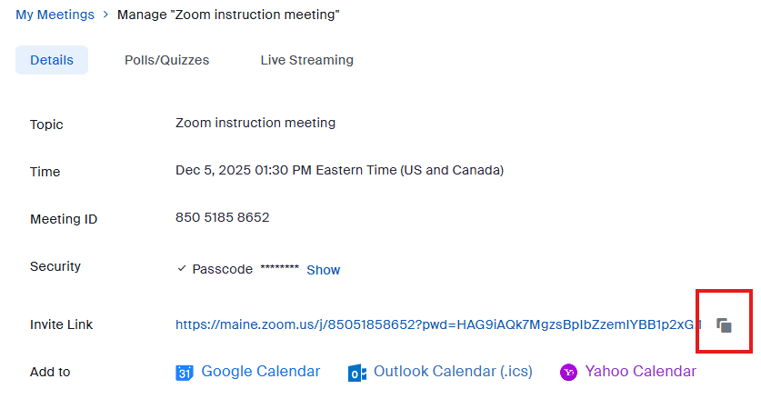
- You can now paste the link into an email to anyone you wish to invite.

Starting a Meeting
Zoom meetings can take place in the Zoom app or in a browser online. We recommend using the app if possible. Both methods are started from the USM Zoom page.
Go to the UMaine Zoom Account and sign in using your maine.edu account. This will open the Zoom Workplace.
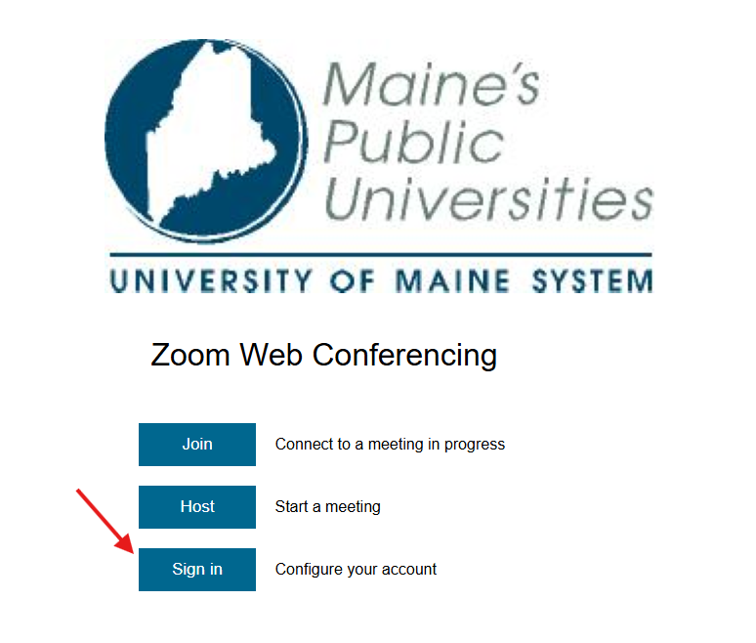

Open in the Zoom App
- Click the “waffle” at the top right, and select Meetings. The Meetings page will open in a new tab.
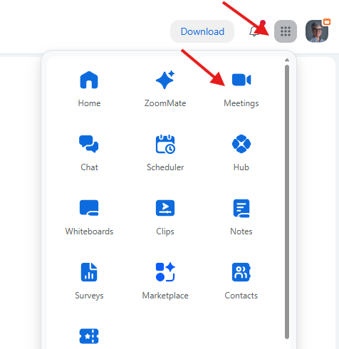
- Hover your mouse over the meeting you would like and click Start.
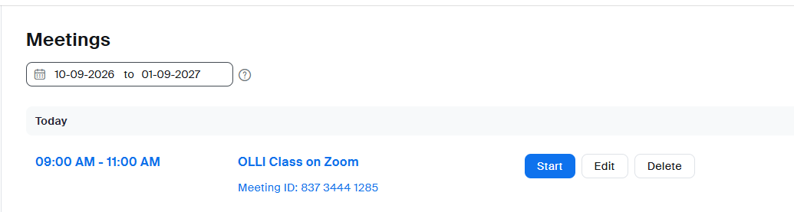
- Zoom will launch its app. Click Start to begin the meeting.
- You will get a prompt asking if you want to start the AI Companion. Click on “Start AI Companion.” A message will pop up that the class is being transcribed.
- If you would like to view the transcript in real time, click the More button in the toolbar and select Transcript.

In an online browser
If you don’t have the Zoom app downloaded on your device, you can use Zoom in the browser.
- Find the class in your calendar. If it is within 15 minutes of the scheduled start time, a Start button will be visible.
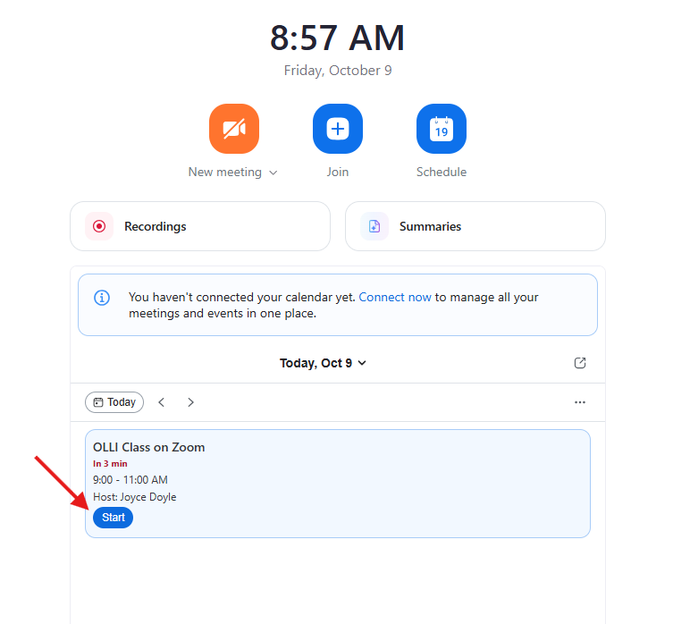
  - If you don’t see Start, click on the meeting name and choose Start in the popup window.
  - If you only see “Join,” you are not logged into the account that created the meeting and are not a meeting host. If you have another Zoom account, log in with that.
- Click the Zoom AI icon in the bottom toolbar to turn transcripts on.
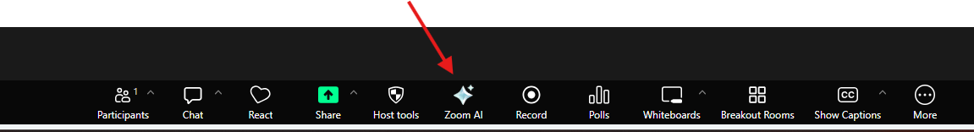
- You don’t need to view the transcript for it to record your meeting. However, if you wish to see the transcript in real time, it will not show unless you turn on Show Captions. Click on the CC Show Captions button in the bottom toolbar. You may be asked to select your preferred language.
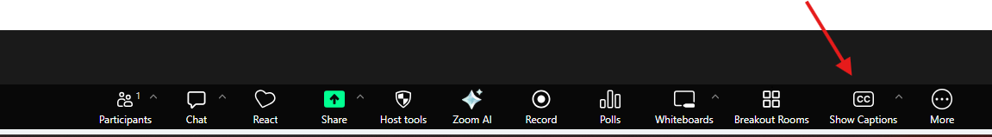
- To see the transcript in real time, after turning on captions, click the carat (the upside down “v”) beside Show Captions and select “View full transcript.” The transcript will open in a window to the right.
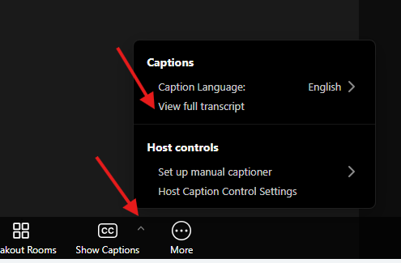 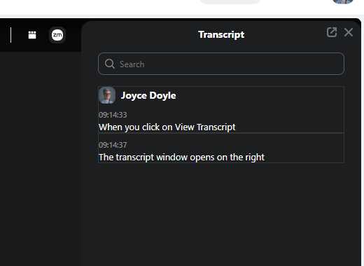
- You can close the transcript in the meeting and turn off closed captioning without impacting the final transcript.

Creating a Co-Host
You will need to make your instructor a co-host. This can be done when creating the meeting (see “Scheduling a Meeting” above) or it can be done during the meeting itself.
- Click the Participants button in the tool bar.
- Hover over the person’s name who needs to become a host.
- Click More and select Make Host.
If you’re unable to attend a class and no one else is assigned as a host, you will want to share your Host Key with someone who can then claim the meeting as a host when they enter. Anyone with your Host Key can run your meeting. Your Host Key is the same for all meetings that you create.
Find your Host Key:
- Click on your picture or initials in the upper right corner of the Zoom page to the right of the waffle icon.
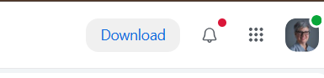
- Click on your name from the dropdown menu.
- Scroll down to view the Host Key. To see the number, you need to click the “eye” icon.
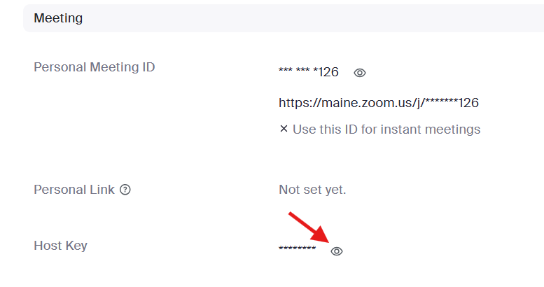

To Claim Host
Once logged into the Zoom meeting, anyone with the Host Key can claim host. In the meeting, click on Participants in the bottom Zoom toolbar. A window will open on the right. Click “Claim Host” at the bottom of the window. Enter the Host Key.

Participants Joining the Meeting
Participants can join the meeting by clicking on the link you shared with them. They may see a pop-up box asking to Open Zoom Meetings.
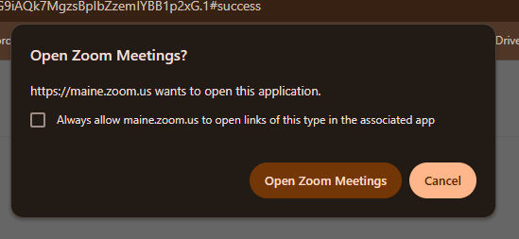
To share a link when already in the meeting or provide a student with a call-in phone number:
- Click on Meeting Info in the bottom tool bar.
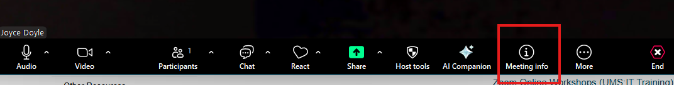
- Copy the Invite link as directed above.
- Scroll down to view the telephone numbers and Meeting ID. Anyone calling in to the meeting will need the Meeting ID.

Seeing Zoom Controls in the Meeting
Zoom defaults to hide controls. To see the buttons:
- On a desktop: wave your mouse over the Zoom screen.
- On a phone or tablet: tap the screen.

Transcription
If you are recording your meeting, transcription will be included. If you are not recording, you will need to activate AI Companion to start the transcript.
When you start your meeting, you may see a message offering to Start AI Companion. Click on Start.
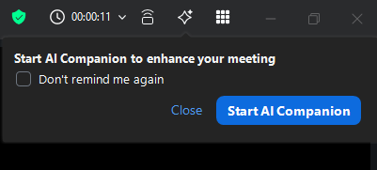
If you don’t see this message, you can select the AI icon from the top right menu bar. And make sure Generate Transcript is checked. Then click Start.

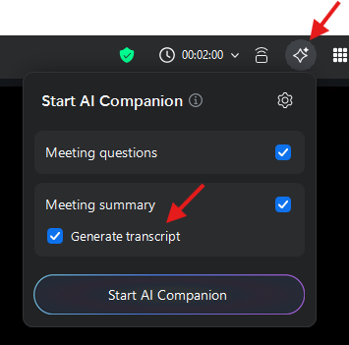
You may see the AI Companion open in a pop-up window on the right. If you don’t want to ask AI any questions, you can just “X” out of this window.
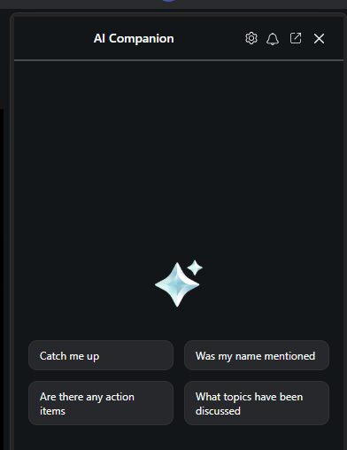
After class, you will need to download the transcript.
Go to your UMaine Zoom account.
- From the Zoom Workplace, click on Recordings (even if you didn’t record your meeting). A new tab will open in your browser.
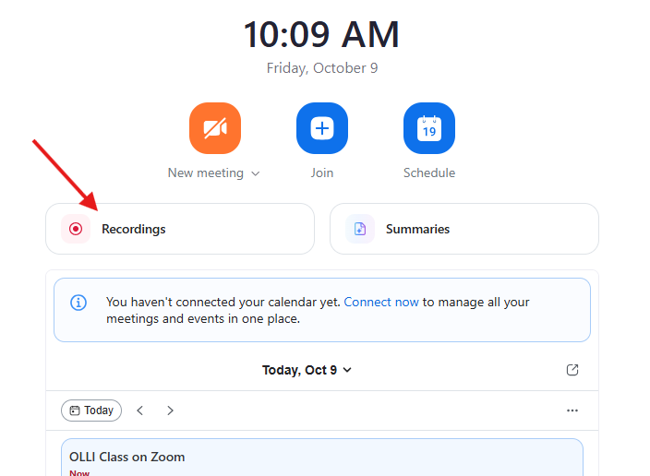
- If you recorded your meeting, you can access the recording here. To find the transcript, click on Transcripts in the top menu.
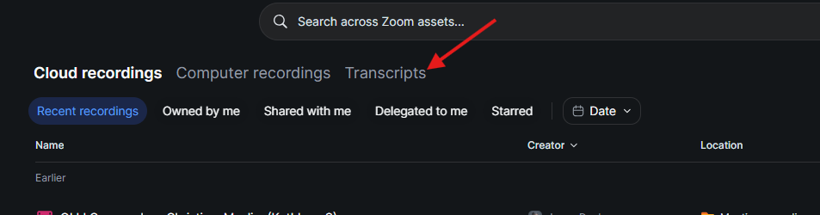
- Hover over your class and you will see 3 dots appear at the end of the row. Click on the dots, and select Download.
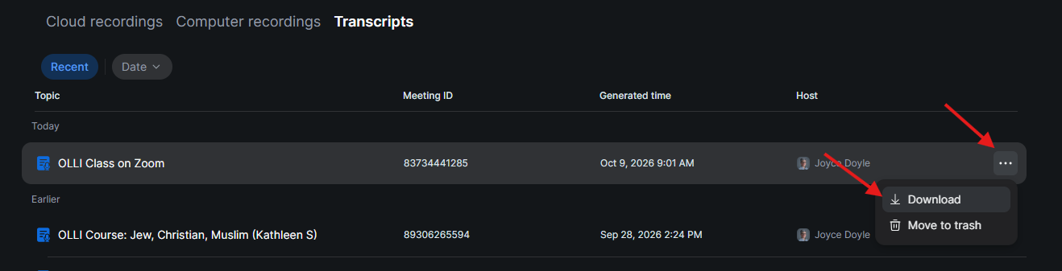
- A .txt file will download to your computer. This text file will have the full transcript of your class.

Microphones and Cameras

Turn a Microphone or Camera On/Off
Unless you set it otherwise, microphones will be automatically turned on when participants join Zoom. Once in the meeting and they confirmed their microphones are active, we suggest muting unless speaking to reduce background noise.
Participants can turn their own microphones and cameras on and off by clicking on the Audio or Video buttons in the bottom tool bar:
Alternatively, if their microphone is on mute, they can hold down the space bar to temporarily unmute.
To turn a participant’s microphone on or off for them:
    - Click on Participants in the bottom tool bar. A window will pop up showing the list of current and invited participants.
    - Each participant will have 2 icons to the right of their name: a microphone and a camera. Hover over the icons and you will see an option to Mute the participant. 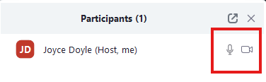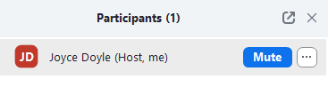

Trouble Shooting Audio

Testing speakers and microphones
Participants can test their speakers and microphone while in the meeting.
- Click on the caret ^ to the right of the Audio button in the tool bar.
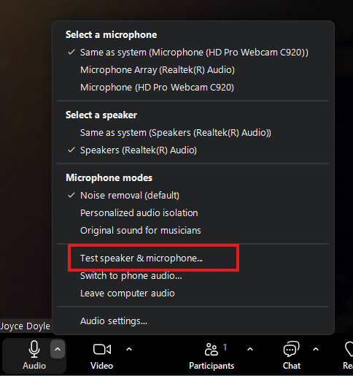
- Click on Test speaker and microphone.

Switching to Phone Audio
If the test fails and the participant needs an alternative way to hear the class, they can call in via phone.
- Click the “Switch to phone audio” directly below the Test in the menu. The phone numbers and meeting ID will be displayed.
- The participant can call one of the numbers and enter the Meeting ID.
- Once connected by phone, be sure to either:
- Click the Computer Audio toggle in the audio options menu used above and “Leave computer audio” or
- Mute the computer speakers.

Echoing and Feedback
Echoing is usually the result of a participant who has more than 1 audio method open – a computer and a phone, or 2 computers logged into the meeting. If there are 2 people the same physical space taking part in the class on their own devices, they cannot both use the audio. To avoid echoing:
- Ask if anyone is using two methods and to turn off the sound and microphone on one of them.
- Ask everyone to remain muted unless speaking, and to re-mute when done.

Change Your Background
Zoom offers the ability to change the background and hide the space behind the participant.
Click the caret ^ to the right of the Video icon in the tool bar
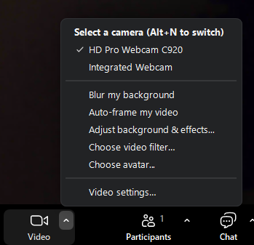
- Here you can select to “Blur my background,” “Adjust background effects” or “Choose a background” to select a background picture or to turn an existing background effect off.

Participating in Class

Change Your Screen View
Each participant can choose to see the camera of whoever is speaking, or the cameras of all participants.
- Click on View in the upper right corner.
- Select the view you wish. Most common are Speaker or Gallery (all participants).
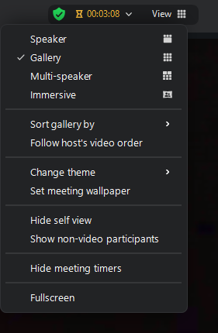

Raise Your Hand and Reactions
Participants can raise their hands and react to the content of the course. Click on React in the tool bar and select Raise Hand, or react with a thumbs up, clapping, a heart, etc. When a participant’s hand is up, a button will appear toward the bottom of the screen so they can lower it again. (Users often get confused between the Raise Hand bar and the “clapping” icon.)
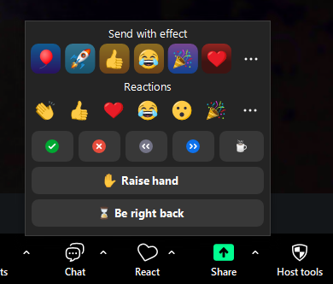

Chat
Remember you can direct message someone without sharing with the rest of the class so there is no distraction. Click on Chat in the bottom tool bar so the Chat window appears. You can use the dropdown menu to select who to chat with, or you can chat the entire group.

Rename Participants
- In the Participants list, hover over the person you wish to rename. You will see an option to Mute appear with an ellipsis (…) next to it.
- Click the ellipsis and you will see an option to rename the person.
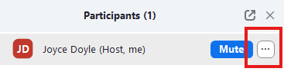
Participants can rename themselves following the same steps.

Closed Captioning
To activate Closed Captioning:
- Click on More in the tool bar.
- Click Captions.
- You will now see a button labeled Show Captions in the tool bar. Click to activate Closed Captioning.

Sharing a Screen

Sharing
*When you share a screen, your view of the class participants will be minimized and set off to the side. If you wish to see more participants, expand that view by clicking on the double arrows in the upper right corner:
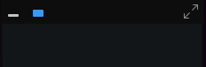
Meetings are generally set to allow anyone to share. To share a screen:
- Click on the Share button in the tool bar
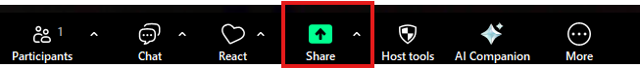
- Click the content you wish to share. A blue box will appear around your selection.
  - Entire screen – Everything on the screen will be shown to the group. This is great for sharing a PowerPoint slide in presentation mode or a video that is on full screen. *Be aware anything you open will be seen by the group.
  - Application windows – Only the window you select will be shown to the group. This is best when sharing a specific application (a spreadsheet, a document, etc.) while you see other items on your own screen that are not shared.
  - Note: If you are using Zoom in the web browser, these options are provided in tab format. Click through the tabs to find the view you wish to share.
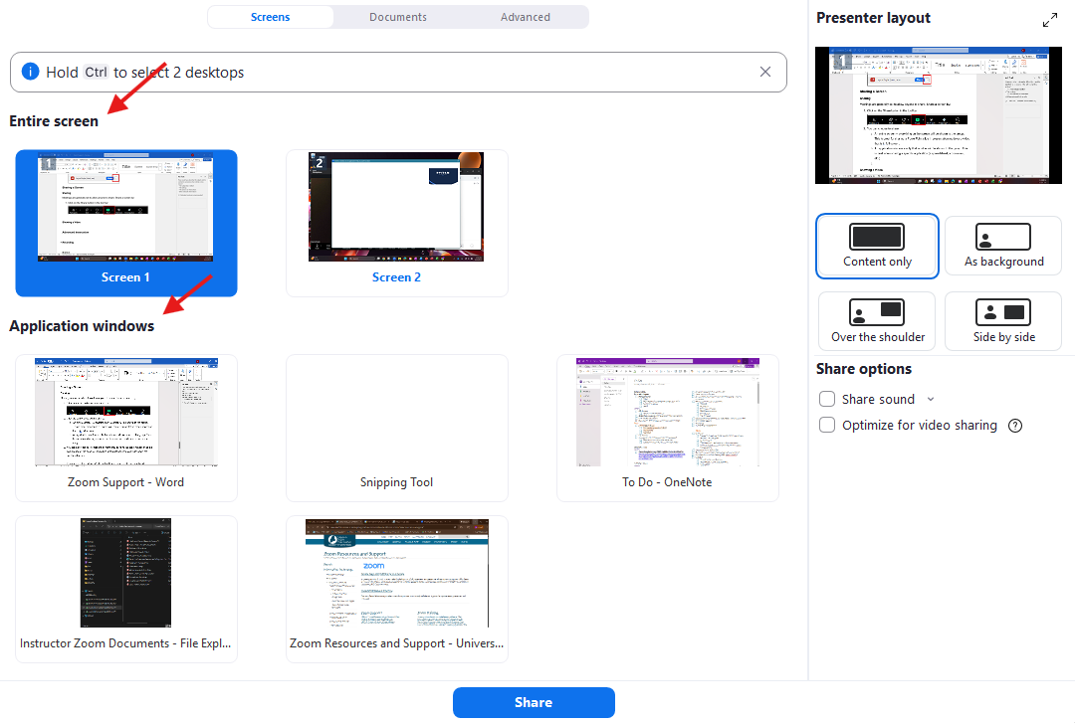
- You can also choose to share the content only, to have the content appear as the background of the speaker, and other configurations by selecting them in the right-hand column.
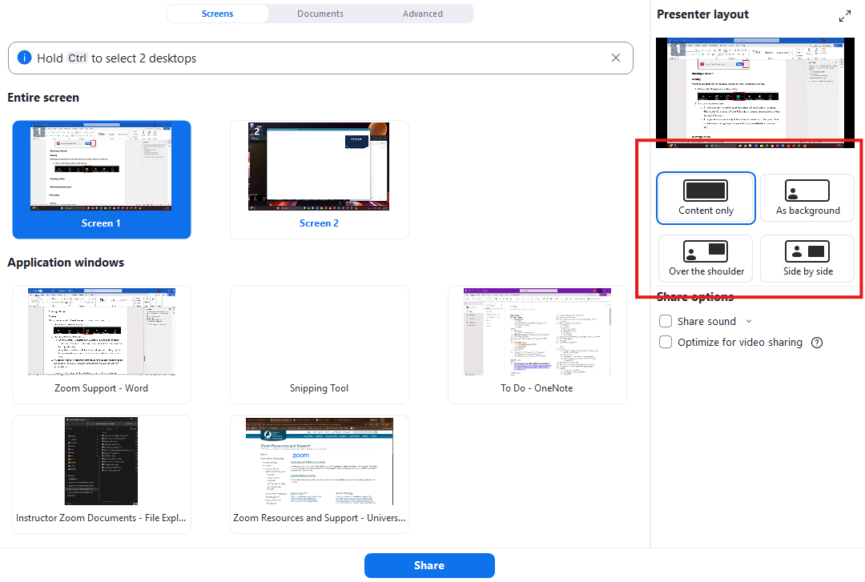
- Click Share at the bottom of the screen.
- The box around your shared content will be a bright green and you will have an option to Stop share at the top.
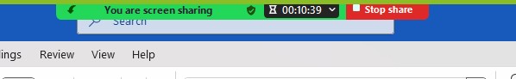
- The view of the speaker and class will appear as a small pop-up box. You can adjust this box using the resize buttons.
- If you lose your Zoom window, look for the Zoom icon in the computer task bar. 

Showing a Video
If you are sharing a video:
- Click on Share and select the screen or application you want to show.
- Click on the Share Sound checkbox in the right-hand column. (In the web browser version, the “Share with system audio” toggle is at the bottom of the share option window.)
- Do not select to Optimize for video sharing – this will slow down streaming of the meeting.
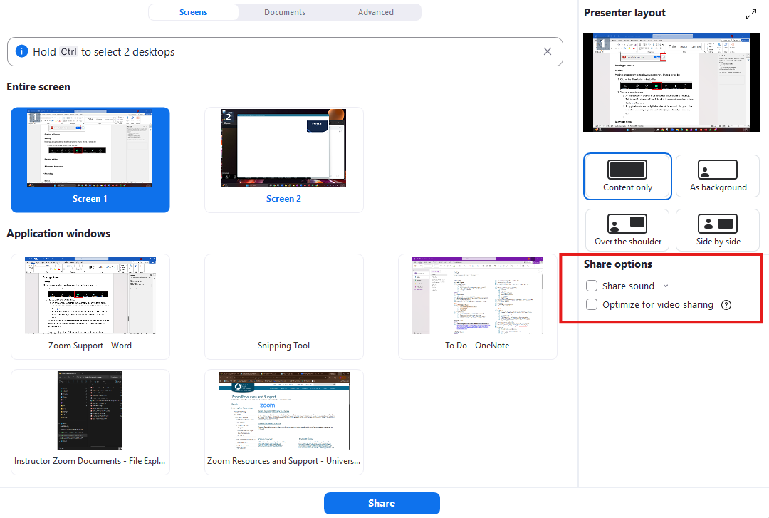
Additional Tips
Find some additional tips on sharing your screen during a Zoom class here.

Advanced Instruction

Recording
You can record your class and share it with students who may miss the session. We recommend:
- When you create your Zoom meeting, you can elect to automatically start recording for every class. However, be aware that the recording will start when the Zoom meeting is opened – which may mean 10 to 15 minutes of chatting before class begins.
- Be sure to pause recording during the class break, and restart recording when you return to session.
- If your class includes viewing a video/movie, pause recording during the video and resume recording after the video is complete to avoid reproduction of copyrighted material. If possible and requested, share the video link with students after class.
To start recording:
- Announce to everyone in the meeting that you are going to start recording.
- Click on the Record button in the bottom menu. (If you don’t see it, click on the More button in the tool bar.)
- Hover over Record in the menu and select Record to the Cloud.
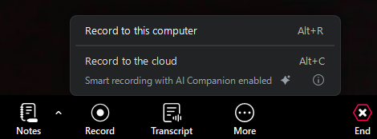
To share the recording after class:
- Log into your Zoom account.
- Click on Recordings. A new tab will open.
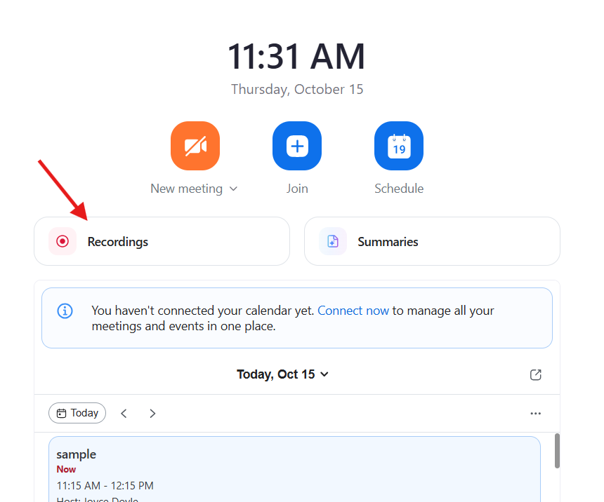
- The view defaults to “Recent recordings.” Look for the recording you want to share. If you don’t see it, click on “Owned by me” to see more recordings.
- Hover over the title of the recording and a menu will appear.
- Click the “link” icon to copy the link and passcode. You can now paste the link and passcode into an email to students. (Be sure to make the link accessible using plain language.)
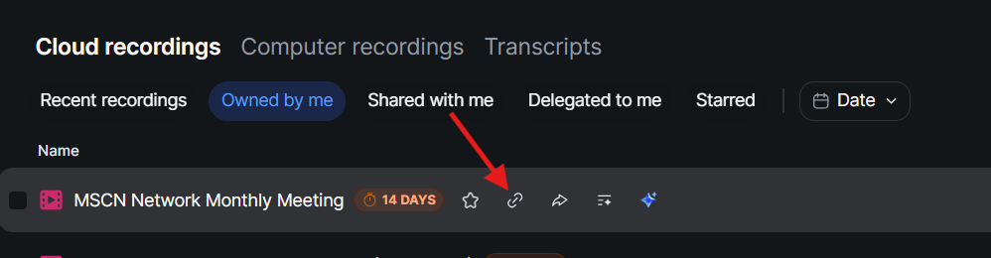
Recordings automatically delete after 14 days. To keep your recording longer:
- Click on the arrow icon in the recording list.
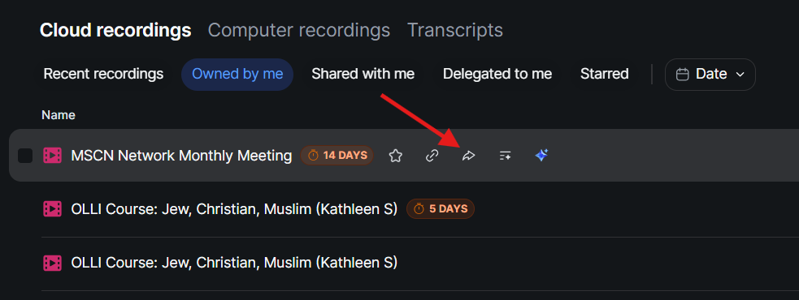
- A popup window to Share will appear. X out of this window.
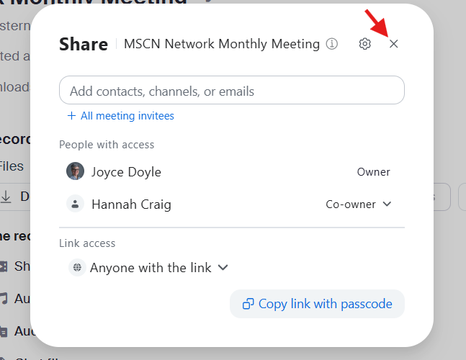
- You can now select to disable auto-delete for that recording.
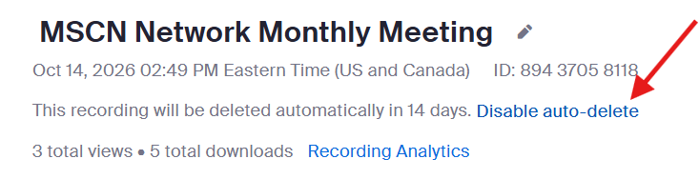
- Be sure to return to your recording list after class is complete and delete any recordings you no longer need to store.
  - From the recording list, hover over the recording title and select the ellipses (…) on the far right.
  - Scroll down the popup menu until you see Move to Trash.
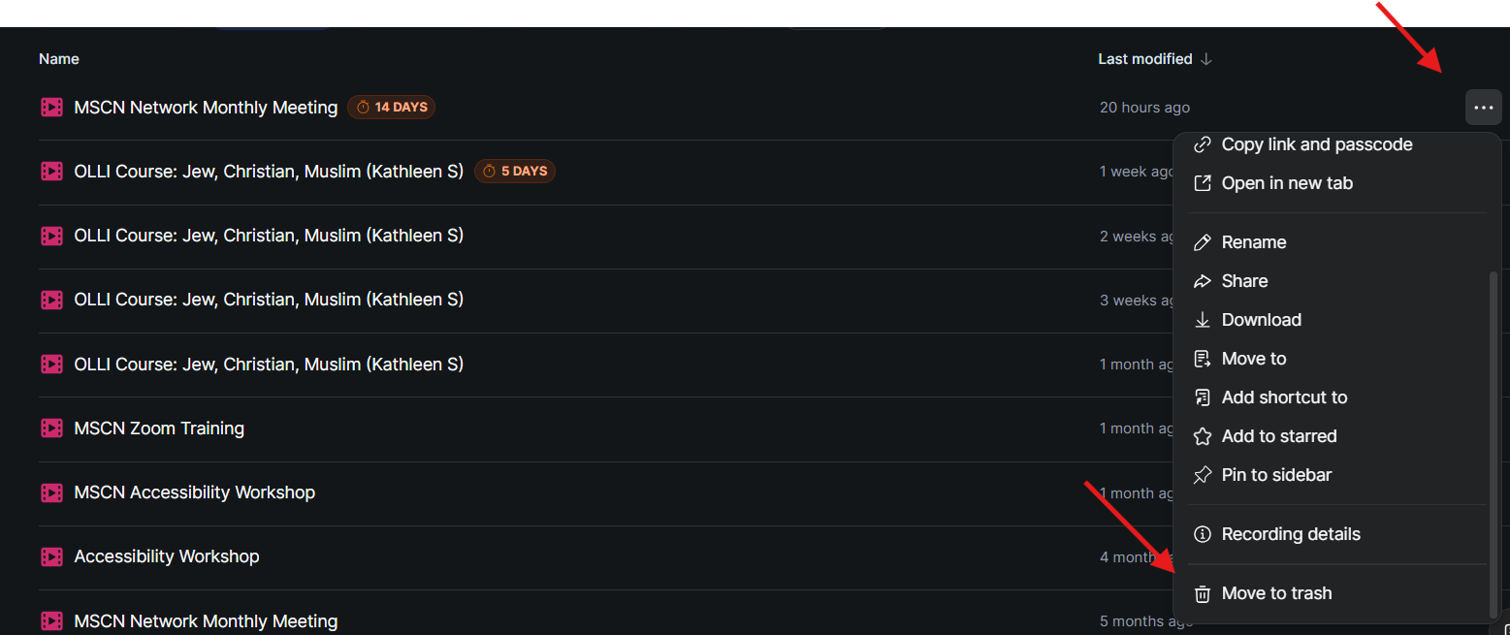

Breakout Rooms
You can send participants to their own workgroups by using Breakout Rooms.
- Click on Breakout Rooms in the tool bar.
- Enter how many rooms you want. For example, if you have 20 students and you want them in groups of 4, you will need 5 rooms.
- Zoom will assign students automatically – or you can manually assign rooms or allow the students to select their own room.
- Click Create.
  - You can move participants to different rooms as desired.
  - If you’re unhappy with the combination of participants in each room you can Recreate them or Add room using the buttons on the bottom of the pop-up window.
  - Options allows you to change the settings of your rooms, and set a timer to close out the rooms. You can still close the rooms any time manually.
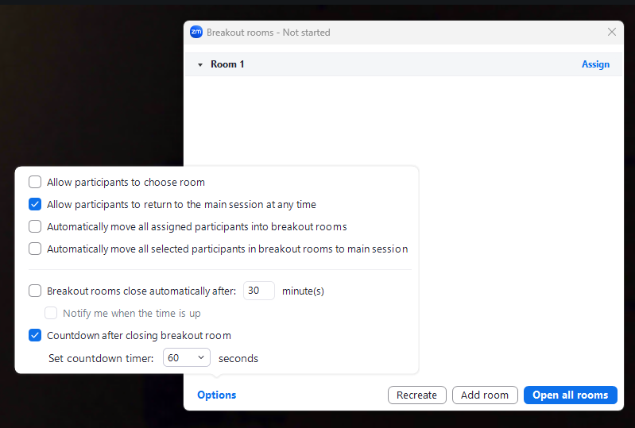
- Students will not go to the rooms until you Open all rooms.
  - If you need to send a message to everyone while they’re in their rooms, use the Broadcast button and the message will appear at the top of all participants’ screens.
  - You can join different Breakout Rooms by clicking Join next to the room you want to attend.
    - To leave the Breakout Room without ending the meeting, click on Leave Breakout Room. You will be returned to the Main Session.
  - If someone doesn’t go to their Breakout Room or joins class after the rooms are created, you will see them listed as Unassigned and will have an option to assign them or use the Recreate button. (If the rooms are already open and participants are in them, the Recreate button will not impact the rooms but will assign the newcomer to a room.)
- When ready to bring everyone back to the Main Session, click on Close All Breakout Rooms. There will be a 60-second countdown before all rooms are closed and participants are sent back to the main Zoom meeting.

Polling

Prior to the Meeting
We recommend creating a poll prior to the meeting, if possible, to save time.
- After you have created the meeting, go to the meeting list in your account and on the meeting title.
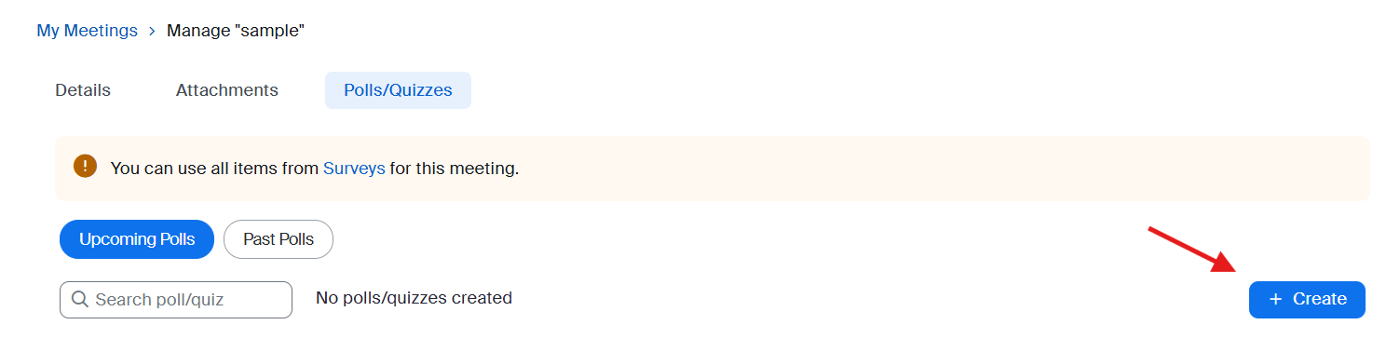
- Click Create.
- You can title the poll and add questions.
- Click Save in the upper right; select Save as a Meeting Poll.
  - In the Meeting
- Click on Polls in the menu bar.
- If there is no poll already created, click Create. Or, select the poll you created in advance.
- When ready to ask the participants to complete the poll, you can launch it by hovering over the poll name and clicking Launch.
- The poll results will show on your screen.
- When done, click End poll.
- You can Share results and then Stop sharing if desired.
- X out of the poll app when finished.

Whiteboard
Access Whiteboards in the tool bar menu. Whiteboards allow everyone in the meeting to draw or write just like it’s chalkboard.
- If you created a Whiteboard when you set up the meeting, you can open existing Whiteboards.
- If you want to create a new one, select New Whiteboard.
- Please note: Whiteboards will not be available after class unless the participant has a maine.edu account.

iPhone and iPad Users
Zoom tools and screens appear differently on phones or tablets. Students asking for help may see tools in different places. Be sure to review the following before class:
iPad User Guide to Zoom
iPhone User Guide to Zoom

Online support
Zoom Support online

Shortcuts
These shortcuts are available to help you move rapidly around Zoom.

Meeting
Ctrl+Alt+Shift: Change focus to Zoom Meeting controls (on top when sharing screen)
PageUp: View the previous page of video participants in gallery view
PageDown: View the next page of video participants in gallery view
Alt: Toggle the option Always show meeting controls in General settings
Alt+F1: Switch to Speaker view
Alt+F2: Switch to Gallery view
Alt+F4: Close the current window
Alt+V: Start/stop video
Alt+A: Mute/unmute audio
Alt+M: Mute/unmute audio for everyone except host (for host only)
Alt+S: Open share screen window or stop screen share if already sharing
Note: This will only work when meeting control toolbar has focus.
Alt+Shift+S: Show/hide windows and applications available to share
Note: This will only work when meeting control toolbar has focus.
Alt+T: Pause or resume screen share
Note: This will only work when meeting control toolbar has focus.
Alt+R: Start/stop local recording
Alt+C: Start/stop cloud recording
Alt+P: Pause/resume recording
Alt+N: Switch camera
Alt+F: Enter or exit full screen mode
Alt+H: Show/hide in-meeting chat panel
Alt+U: Show/hide participants panel
Alt+i: Open invite window
Alt+Shift+i: Copy invitation link
Alt+Y: Raise/lower hand
Alt+Q: Display prompt to end or leave meeting
Alt+Shift+R: Begin remote control
Alt+Shift+G: Revoke/give up remote control permission
Ctrl+2: Read active speaker name
Ctrl+Alt+Shift+H: Show/hide floating meeting controls
Ctrl++: Increase chat display size
Ctrl+-: Decrease chat display size

Team Chat
Alt+Shift+T: Screenshot
Ctrl+W: Hide current chat session
Ctrl+Up: Go to previous chat
Ctrl+Down: Go to next chat
Alt+Left: Back in chat history
Alt+Right: Forward in chat history
Ctrl+N: Start a new chat
Ctrl+L: Focus to list of all chats and channels
Ctrl+U: Focus keyboard to latest message in current group chat or channel
Ctrl+Alt+i: Add member to current group chat or channel
Alt+N: Jump to start of new messages in the current group chat or channel
Ctrl+K: Insert a hyperlink
Note: There are also additional shortcuts for editing chat messages.

Phone
Ctrl+P: Call highlighted phone number
Ctrl+Shift+A: Accept inbound call
Ctrl+Shift+E: End current call
Ctrl+Shift+D: Decline inbound call
Ctrl+Shift+M: Mute/unmute call
Ctrl+Shift+H: Hold/unhold call
Ctrl+Shift+T: Transfer call

General
Alt+F4: Close current window
Ctrl+F: Search
F6: Navigate among Zoom popup windows.
Ctrl + Tab: Switch to next product tab.
Ctrl + Shift + Tab: Switch to previous product tab.
Ctrl + 1-8: Switch to the specified product tab.
Ctrl + 9: Switch to the last product tab.
Alt+L: Switch between Portrait and Landscape views
Ctrl+Alt+Shift+D: Start network diagnostic

